CHAPTER 9: Energy transmission
Worksheet 9.6

Waves
Science Quest 9: pages 326–7
Student: Class:
1. Examine the following diagram of a wave.

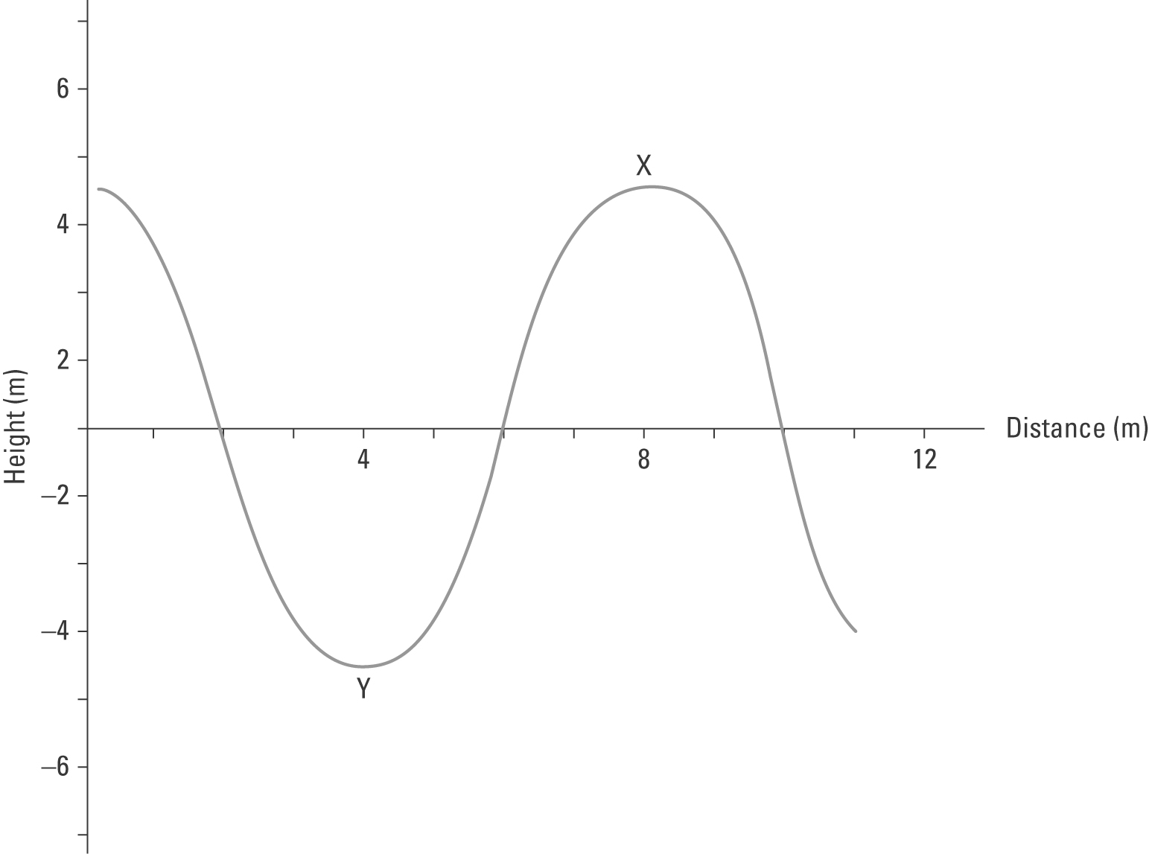
(a) Identify the type of wave illustrated.
(b) Two parts of the wave are labelled X and Y. Name these parts.
X: ..................................................................... Y: .....................................................................
(c) Use the scale to determine the wavelength and amplitude of the wave.
Wavelength: ............................................................
Amplitude: ..............................................................
(d) If the velocity of the wave is 16 m/s, calculate the frequency of the wave.

CHAPTER 9: Energy transmission
Worksheet 9.6

Page 2

2. Consider the following diagram in which a mass is suspended from the end of a spring that is clamped to a retort stand.

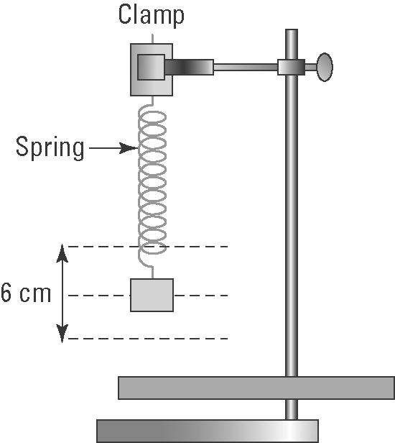

(a) The mass is pulled down and let go. It begins to oscillate up and down. Identify the type of wave motion in the spring.

(b) Determine the amplitude of the vibration.

(c) 20 oscillations are made in 5 seconds. Determine the frequency of the oscillation.

3. Electromagnetic waves are transverse waves which have very high frequencies. Light is an electromagnetic wave. Describe the nature of an electromagnetic wave.

4. The following diagram shows the regions of the electromagnetic spectrum. Identify the missing regions X, Y and Z.
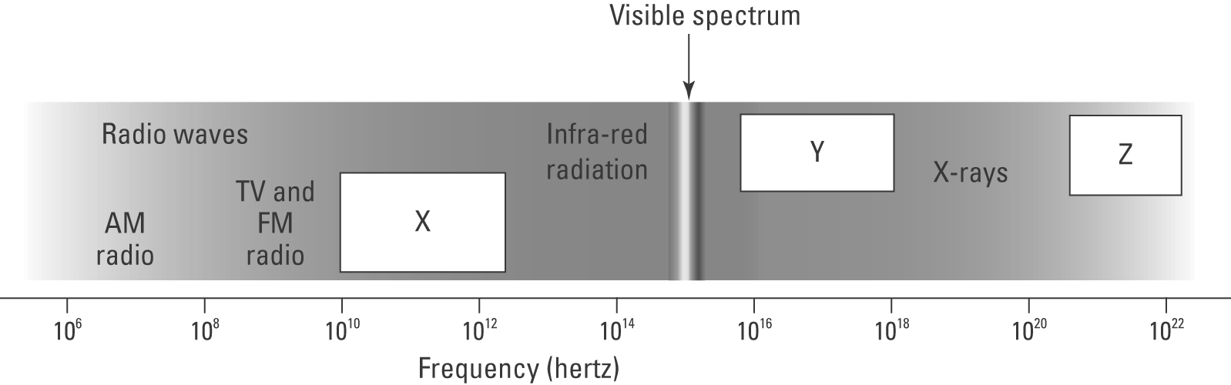

X: ....................................................
Y: ....................................................
Z: .....................................................

